A PROJECT SCHOOL REPORT ON
MobilePlantViT : A Mobile-friendly Hybrid ViT for Generalized
Plant Disease Image Classification.
Submitted By
P. VARUNTEJ REDDY 23P81A6651
ADDITI NAIK 23P81A6601
K.VAISHNAVI 23P81A6637
CH.ASHWANTH REDDY 23P81A6637
SAI KRISHNA 23P81A6651
Under the guidance of
Dr. SHILPA GUPTHA
Assistant Professor, AIML


KESHAV MEMORIAL COLLEGE OF ENGINEERING
Koheda Road, Chinthapallyguda (V), Ibrahimpatnam (M), R.R. Dist. – 501510 (T.S)
January 2025

CERTIFICATE
This is to certify that the project work entitled “MobilePlantViT: A Mobile-friendly Hybrid ViT for Generalized Plant Disease Image Classification” is a bonafide work carried out by “P.Varun tej , Additi Naik, Ch.Ashwanth, K.Vaishnavi, Sai Krishna” of II year IV semester Bachelor of Engineering in CSE during the academic year 2025-2026 and is a record of bonafide work carried out by them.

Project Mentor
DR. SHILPA GUPTA
Assistant Professor, AIML

ABSTRACT

Abstract—Plant diseases significantly threaten global food security by reducing crop yields and undermining agricultural sustainability. AI-driven automated classification has emerged as a promising solution, with deep learning models demon strating impressive performance in plant disease identification. However, deploying these models on mobile and edge devices remains challenging due to high computational demands and resource constraints, highlighting the need for lightweight, ac curate solutions for accessible smart agriculture systems. To address this, we propose MobilePlantViT, a novel hybrid Vision Transformer (ViT) architecture designed for generalized plant disease classification, which optimizes resource efficiency while maintaining high performance. Extensive experiments across diverse plant disease datasets of varying scales show our model’s effectiveness and strong generalizability, achieving test accuracies ranging from 80% to over 99%. Notably, with only 0.69 million parameters, our architecture outperforms the smallest versions of MobileViTv1 and MobileViTv2, despite their higher parameter counts. These results underscore the potential of our approach for real-world, AI-powered automated plant disease classification in sustainable and resource-efficient smart agriculture systems.

CONTENTS
S.No. Title Page No.

ABSTRACT i
TABLE OF CONTENTS ii
LIST OF FIGURES iii
LIST OF TABLES iv

1. Introduction 1

2. Literature Survey
2.1 Existing Research and Techniques 3
2.2 Limitations and Drawbacks 4
2.3 Distinctive Aspects of Our Methodology 5

3. Proposed Work Architecture, Technology Stack, Implementation Details
7
3.1 Model Architectures
14
3.2 Technology Stack and Implementation
17
3.3 Dataset
18
3.4 Interfaces and Communication

4. Results & Discussions
4.1 Results 23
4.2 Discussions 24
- Conclusion & Future Scope 25
- References 26

LIST OF FIGURES
Fig. No. Figure Name | Page No.
1 Vision transformer architecture | 8
2 Efficientnetv2 model architecture | 13
3 Sign in page | 19
4 Creation of account page | 19
5 Home page display | 20
6 Final output page | 20
7 Comparision table
8 Bar graph representation

LIST OF TABLES

Table No. Table Name Page No.

1 Dataset classes 17
2 Dataset split 17
3 Model accuracy comparison 23

CHAPTER 1

INTRODUCTION

Plant diseases represent a significant threat to global food security, impacting crop output and endangering the livelihoods of millions of people. According to the Food and Agriculture Organization (FAO), up to 40% of global crop pro duction is lost annually due to pests and diseases, amounting to billions of dollars in economic losses and exacerbating food scarcity challenges [1]. Automated and accurate identification of these diseases is essential to mitigate crop damage and ensure sustainable agricultural productivity, and deep learning (DL) has revolutionized the field of automated plant disease recognition [2], [3] over the past decade. Convolutional neural network (CNN)–based models have demonstrated notable success in extracting discriminative features from complex leaf images, achieving competitive performance in classification Moshiur Rahman Tonmoy is with the Department of Computer Science and Engineering, University of Asia Pacific, Dhaka 1205, Bangladesh (email: moshiurtonmoy.bb@gmail.com) Md. Mithun Hossain is with the Department of Computer Science and Engineering, Bangladesh University of Business and Technology, Dhaka 1216, Bangladesh (email: mhosen751@gmail.com) Nilanjan Dey is with the Department of Computer Science and Engi neering, Techno International New Town, Kolkata 700156, India (email: nilanjan.dey@tint.edu.in) M. F. Mridha is with the Department of Computer Science, Ameri can International University-Bangladesh, Dhaka 1229, Bangladesh (email: f iroz.mridha@aiub.edu) , Senior Member, IEEE, M. F. Mridha . In recent years, Vision Transformers (ViTs) have emerged as a compelling alternative to CNNs and have shown remarkable performance gains across a wide range of computer vision tasks, including classification, suggesting their potential applicability in plant disease diagnosis . However, deploying high-performance DL models to resource-constrained devices remains a major challenge. For instance, the high computational and memory demands of ViTs can be prohibitive in low-power scenarios despite their state-of-the-art performance. Likewise, conventional CNN backbones also face trade-offs between model capacity and hardware limitations, spurring researchers into lightweight models. There has been significant progress toward developing compact models including ViTs , and models such as Mo bileViTv1 and MobileViTv2 are the prime examples. They incorporate efficient mechanisms for compressed feature representations and streamlined designs to narrow the performance gap between standard ViT and CNN counterparts . Nonetheless, these methods can remain computationally intensive in ultra-low-power devices, underscoring the need for optimizations that balance accuracy and maximum efficiency in ensuring precision agriculture accessibility globally. In the context of scaling AI-based solutions for global precision agriculture advancement across underrepresented farming communities, tailored lightweight architectures become even more critical for cost-efficient automated agricultural tasks [13]. As high-end smart agriculture tools and automated systems often put significant financial barriers to users from low-income regions, introducing on-device smart systems in tegrated with tailored lightweight AI models demanding mini mum computational overhead could be a feasible choice. With this motivation, we investigate lightweight yet generalized DL models in the plant disease classification domain and propose MobilePlantViT, a hybrid ViT architecture tailored for accurate plant disease image classification maintaining well balance between performance and efficiency. The key contributions of this study can be summarized as follows: • We propose a generalized lightweight ViT for accurate plant disease image classification, with only 0.69 million parameters • Our model achieved competitive accuracy across exten sive experiments on multiple plant disease datasets • Despite having fewer parameters, our model outper formed equivalent lightweight ViTs with higher parameter counts.

CHAPTER 2

LITERATURE SURVEY

2.1 Existing Research and Techniques
Over the years, researchers have made significant progress in developing automated plant disease recognition systems using deep learning, particularly CNN and Transformer-based models. Rehman et al. [14] used CNNs to detect diseases in vegetables and addressed limited dataset issues, but scalability remained a challenge for underrepresented crops. Similarly, Demilie [15] achieved up to 99.6% accuracy using ensemble CNN models, though these methods increased computational costs, limiting deployment on low-power devices. Gupta et al. [16] and Bezabih et al. [17] combined VGG16 and AlexNet for pepper disease detection, achieving high accuracy but relying on older, heavier architectures. Hassan and Maji [18] and Mzoughi and Yahiaoui [19] enhanced CNN performance with segmentation techniques to reduce complexity, though these required extra preprocessing steps.
Further, advanced models such as T-CNN [20] and DCNN-19 [21] improved classification accuracy but suffered from high inference times on lightweight hardware. Chen et al. [23] demonstrated that deep transfer learning with MobileNet-V2 can improve detection of subtle disease symptoms, while Zeng et al. [24] introduced DIC-Transformer, combining Faster R-CNN and Transformers for both disease detection and description—though the two-stage design made it computationally intensive. Kalpana et al. [25] used Swin Transformers with residual CNNs for improved feature extraction, and Zhu et al. [26] proposed MSCVT, a hybrid CNN-ViT model with 99.86% accuracy and reduced parameters.
Other researchers, such as Teki et al. [27], applied Vision Transformers (ViT) and Shifted Window Transformers to thermal images, achieving strong accuracy but requiring costly imaging equipment. Borhani et al. [28] explored lightweight ViTs that offered better accuracy than CNNs but at slower speeds. Bathula et al. [29] introduced MFF-ADNet, combining ViT, VGG16, and a variational autoencoder for 7.18% improvement, though this added complexity and memory usage. Wasi Ullah et al. [30] presented AppViT, a hybrid model combining CNN and attention layers, reaching 96.38% precision while remaining relatively lightweight. Li et al. [32] proposed PDLM-TK with tensor features and knowledge distillation, balancing accuracy and efficiency. Thakur et al. [33] combined CNNs and ViTs, achieving 98.86% accuracy with only 0.85M parameters, showing promise for compact architectures. Finally, Muthireddy et al. [34] and Chougui et al. [35] showed that incorporating handcrafted features and attention improves model performance, though such features are hard to design and often lack generalization.
Overall, past studies demonstrate that CNN and ViT-based architectures are highly effective for plant disease recognition. However, most focus on specific crops or prioritize accuracy over efficiency, making them impractical for broad, real-world deployment. Hence, there is a strong need for a unified, lightweight, and generalizable architecture capable of accurately identifying diseases across multiple crop types while maintaining computational efficiency.

2.2 Limitations and Drawbacks
Despite major advancements in deep learning–based plant disease recognition, several challenges continue to affect model efficiency and real-world usability. Most CNN and Transformer-based models perform well in controlled conditions but fail to generalize across multiple crops or varying environmental factors. They often require large labeled datasets, high computational resources, and complex preprocessing, making them unsuitable for real-time field applications or deployment on low-power devices. Furthermore, Transformer-based models, though powerful, demand significant memory and training time, while methods using handcrafted features or specialized hardware lack scalability and flexibility. Overall, there remains a clear trade-off between achieving high accuracy and maintaining efficiency, scalability, and practicality for real-world, multi-crop disease detection.

Key Limitations and Drawbacks :
- Crop-Specific Models: Designed for particular crops, limiting cross-crop generalization.
- High Computational Requirements: CNNs and Transformers demand powerful GPUs and large memory.
- Complex Processing Pipelines: Ensemble and segmentation methods increase preprocessing and inference time.
- Limited Field Robustness: Accuracy drops under variable lighting, occlusion, or background interference.
- Large Data Dependency: Require massive, well-labeled datasets for effective training.
- Transformer Overhead: ViT-based models have long training times and high computational load.
- Hardware Dependency: Some methods rely on expensive thermal or hyperspectral imaging devices.
- Manual Feature Extraction: Handcrafted features require expert effort and limit adaptability.
- Poor Scalability: Running separate models for different crops increases cost and maintenance complexity.
- Accuracy–Efficiency Trade-Off: Models optimized for accuracy often compromise speed and deployment feasibility.

2.3 Distinctive Aspects of Our Methodology
his study takes a different approach to plant disease recognition. Unlike many existing works that rely on heavy CNN architectures or focus on developing models for individual crop types, our methodology emphasizes a lightweight, unified, and generalizable design capable of classifying diseases across multiple plant species. Instead of prioritizing accuracy alone, our approach seeks to balance performance, efficiency, and scalability, making it more suitable for real-world agricultural deployment. The proposed architecture integrates efficient convolutional and attention-based mechanisms, allowing it to capture both local and global disease features with fewer parameters and faster inference time compared to traditional deep learning models. This enables reliable disease detection even under challenging conditions such as varying lighting, leaf overlaps, and complex backgrounds.
Furthermore, our method simplifies the overall processing pipeline by reducing preprocessing steps and ensuring compatibility with low-power edge devices, which is crucial for field-based applications. Unlike ensemble or multi-stage frameworks, our model maintains high performance without increasing computational overhead, making it both cost-effective and scalable. Overall, this study contributes a lightweight, robust, and multi-crop plant disease classification model that addresses the major gaps of prior CNN- and Transformer-based approaches, paving the way for efficient and practical agricultural monitoring systems.
Previous studies have explored several approaches, each with its own strengths and limitations:
− Rehman et al. [14] used CNNs for vegetable disease detection but faced scalability challenges for underrepresented crops.
− Demilie [15] employed ensemble CNNs achieving 99.6% accuracy, though the computational load limited edge deployment.
− Gupta et al. [16] and Bezabih et al. [17] combined VGG16 and AlexNet, producing high accuracy but relying on older, heavier architectures.
− Hassan and Maji [18] improved CNNs with segmentation methods, enhancing accuracy but adding extra preprocessing steps.
− Zeng et al. [24] proposed the DIC-Transformer for detailed disease identification and description, but its two-stage design was computationally intensive.
− Zhu et al. [26] introduced MSCVT, a hybrid CNN-ViT model that achieved 99.86% accuracy yet demanded substantial resources.
− Thakur et al. [33] combined CNNs and ViTs for superior performance with fewer parameters, though its field robustness was untested.
By addressing these challenges, our approach introduces a compact and efficient architecture capable of achieving high accuracy, faster inference, and broad generalization—making it a practical and scalable solution for multi-crop plant disease detection in real-world agricultural environments.

CHAPTER 3

PROPOSED WORK ARCHITECTURE, TECHNOLOGY STACK, IMPLEMENTATION DETAILS

This section outlines the architectural design, model framework, tools, and methodologies used to develop the MobilePlantViT model for efficient and generalized plant disease classification. The primary objective of this work is to automate the identification of multiple crop diseases from leaf images using lightweight deep learning architectures optimized for real-world agricultural applications. To achieve this, we explored a hybrid Vision Transformer (ViT) design that effectively combines convolutional neural networks (CNNs) for local feature extraction and transformer-based attention mechanisms for capturing global dependencies. The proposed model aims to maintain high classification accuracy while significantly reducing computational complexity, making it suitable for mobile and edge device deployment.
The architecture integrates Depthwise Separable Convolutions, Group Convolution blocks, and a Convolutional Block Attention Module (CBAM) to enhance feature representation, followed by a Linear Self-Attention–based encoder for efficient context learning. This design enables MobilePlantViT to achieve strong generalization across multiple crop species and varying environmental conditions. Additionally, we describe the technology stack, data preprocessing techniques, and implementation details adopted for model training, optimization, and evaluation across multiple benchmark datasets.

3.1 Model Architectures
In MobilePlantViT, we explore two deep learning architectures for detecting plant diseases, chosen for their complementary strengths in feature extraction:
- Vision Transformer (ViT)
  - Treats plant leaf images as sequences of patches, capturing global relationships across the leaf.
  - Effective in detecting overall disease patterns, such as large lesions or widespread infections.
  - According to the base research paper, ViT performs well for global context understanding but may require more data for fine-grained symptoms.
- CNN + Hybrid ViT
  - Combines CNNs for local feature extraction (like small spots or lesions) with ViT for global context understanding.
  - CNN captures fine-grained disease details, while ViT identifies the overall health pattern of the leaf.
  - The hybrid model, as highlighted in the research paper, achieves higher accuracy and efficiency, making it suitable for real-time mobile deployment.
These architectures form the core of MobilePlantViT, balancing accuracy, computational efficiency, and mobile usability for effective plant disease detection. The following sections explain each model in detail along with their architectural flow and relevance to our task.

VISION TRANSFORMER
Imagine teaching a computer to recognize whether a fruit is fresh or stale just by looking at its picture. Traditionally, we used Convolutional Neural Networks (CNNs), which look at small parts of the image using filters. But there's a newer method called the Vision Transformer (ViT), which views the image in small patches and learns how they relate using a concept called attention.
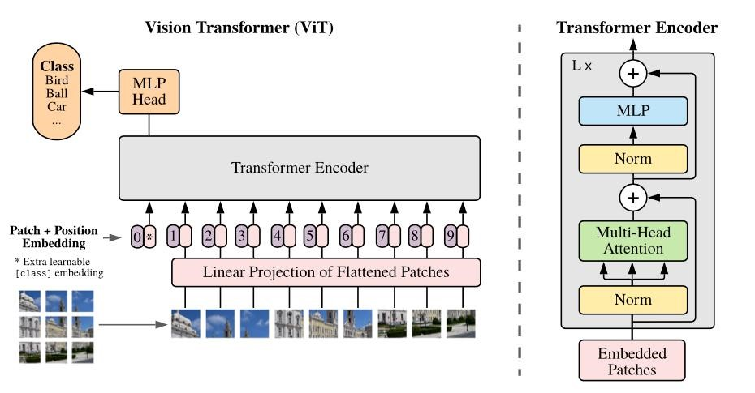
Figure 1: Vision transformer architecture
• Step 1: Breaking the Image into Patches
Think of a big picture like a large mosaic made up of many tiny tiles.
ViT cuts the whole image into smaller square patches for example, 16 pixels by 16 pixels each. Each patch is flattened into a 1D vector (i.e., converted into a long list of numbers). If each patch is P×P pixels and the image has C color channels, the resulting vector has a length of 𝑃² × 𝐶. This list is then converted into a smaller, neat representation called an embedding of size D, which is just a way for the computer to understand and work with that patch.
For example, a 16×16 patch from an RGB image becomes a vector of size 16×16×3 = 768. Patch Embedding = X × W_{e} + b Where:
X = flattened patch vector of size P².C
W_{e} = learnable weight matrix that projects X into embedding space of dimension D b = learnable bias vector

• Step 2: Adding Positional Embeddings
Transformers do not automatically understand the order or position of the input data because they are permutation invariant. This means if you shuffle the patches, the model won’t know their original arrangement. To solve this, positional embeddings are added to each patch embedding. These embeddings encode the spatial position of each patch in the image, allowing the model to know where each piece fits. Additionally, a special learnable token called the classification token (denoted as [CLS]) is added at the start of the sequence. This token will aggregate information from all patches and is used later for classification.
Z0 = [ xcls;x1E;x2E;….;xNE] + Epos Where:
x_{cls} = the classification token embedding x_{i}^{E} = embedding of the i^{th} image patch
E_{pos} = positional embeddings for each token (including the [CLS] token) N = total number of patches

- Step 3: The Transformer Encoder
Now that we have our patch embeddings with position information, the next step is to process them using the Transformer encoder — the core engine of the Vision Transformer. This encoder takes in the full sequence of patch embeddings (plus the [CLS] token) and passes them through multiple layers to help the model understand the image deeply. Each encoder layer has two parts: Multi-Head Self-Attention (MSA): This mechanism allows each patch to interact with every other patch, helping the model learn global context.
Feed-Forward Network (MLP): After attending to other patches, each patch's representation is refined by a small neural network.
This step is repeated L times to refine understanding. Each layer also includes techniques like Layer Normalization and skips connections to make training more stable and efficient.

- Step 4: Classification Head
After the input has passed through all the transformer encoder layers, the model focuses on the output corresponding to the special [CLS] token. It represents the model’s final understanding of the image. To make a prediction, this [CLS] token is passed through a small neural network called a Multi-Layer Perceptron (MLP), which converts it into a set of output values called logits. These logits represent the confidence scores for different classes in our case, for example, whether the fruit in the image is "fresh" or "stale". The class with the highest score is chosen as the final prediction. Y = MLP(Z_{cls}^{(L)})
Where Z_{cls}^{(L)} is the final output of [CLS] token after the class encoder layer, and y is predicted output. ViT lays the foundation, which is further enhanced by models like MiniVit.

HYBRID MODEL
In this architecture, we combine the strengths of Convolutional Neural Networks (CNNs) and Vision Transformers (ViTs) to improve the detection and classification of plant leaf diseases.
After analyzing the performance of individual CNN and Transformer architectures, we designed a hybrid model, named MobilePlantViT, that leverages both their advantages. As shown in the figure, the model begins with an input leaf image, which is first processed by a CNN-based backbone consisting of Depthwise Convolution and Group Convolution layers. These layers extract essential local features such as color variations, leaf textures, and disease spots efficiently.
The extracted feature maps are then passed into a Linear Self-Attention Transformer Encoder, which captures the global relationships and dependencies between different parts of the leaf. This helps the model understand the overall disease pattern rather than relying only on localized areas. By combining local feature extraction (CNN) with global context modeling (Transformer), the MobilePlantViT model achieves improved classification accuracy while remaining lightweight and suitable for mobile deployment.
To further enhance performance, transfer learning is applied by initializing the model with pretrained weights from ImageNet. This helps the model converge faster and generalize better to different plant datasets such as PlantVillage, CCMT, and Sugarcane.
Mathematically, the architecture can be represented in three main steps:
- Feature Extraction: f₍CNN₎ = CNN(x), where x is the input image and f₍CNN₎ are the extracted local features.
- Transformer Encoding: f₍ViT₎ = Transformer(f₍CNN₎), where the self-attention mechanism refines the representation using global dependencies.
- Classification: y = MLP(f₍ViT₎), where y is the final prediction output representing the disease class probabilities.
This hybrid structure allows MobilePlantViT to maintain high accuracy with fewer parameters, offering a balance between computational efficiency and model performance, making it ideal for real-time agricultural disease detection.
Enhanced Model
EfficientNetV2:
The EfficientNetV2 model is an improved and faster version of EfficientNet, designed to achieve higher accuracy with fewer parameters and faster training speed. It follows a progressive compound scaling approach that adjusts depth, width, and image resolution uniformly to balance efficiency and performance. The architecture primarily consists of Fused-MBConv and MBConv blocks arranged in multiple stages.
- StemLayer:
The model begins with a standard convolution layer that captures low-level spatial features from the input image and increases the channel dimensions for deeper processing.
- Fused-MBConvBlock:
Combines the operations of expansion and depthwise convolution into a single step, which reduces memory access and improves computational speed, especially on GPUs and mobile devices.
- MBConvBlock:
A mobile inverted bottleneck convolution with depthwise separable convolutions and squeeze-and-excitation (SE) attention. It efficiently extracts both spatial and channel-wise features while minimizing parameters.
- ProgressiveLearningStrategy:
EfficientNetV2 gradually increases input image size and model capacity during training, allowing faster convergence and better feature learning.
- ClassificationHead:
The final feature maps undergo Global Average Pooling, followed by a fully connected dense layer with softmax activation to predict the plant disease category.

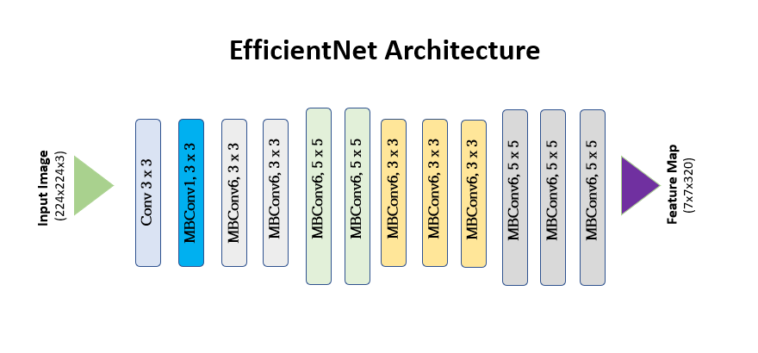
3.2 Technology Stack and Implementation
This section explains the technologies used and the implementation workflow of the MobilePlantViT Plant Disease Classification System.
The system integrates a hybrid deep learning model (CNN + Vision Transformer) for accurate image-based leaf disease detection, along with a Flask-based backend and a React frontend for user interaction and visualization.

🔹 Machine Learning Frameworks and Model Handling
- PyTorch:
Used for building, training, and deploying the MobilePlantViT model. Its flexible dynamic computation graph made experimentation and customization efficient.
- Torchvision & timm:
Provided pretrained backbones and utility functions for model initialization, transformations, and data augmentation.
- CUDA:
Enabled GPU acceleration for faster training and inference during experimentation.
Implementation:
- The MobilePlantViT model was trained and fine-tuned using Google Colab GPU (Tesla T4) for performance and convenience.
- For better memory utilization and stability:
  - Batch size was reduced dynamically based on GPU load.
  - Automatic Mixed Precision (AMP) was used to accelerate training.
  - Gradient clipping was applied to maintain stable updates.
- During preprocessing, all input images were resized to 224×224 pixels and normalized according to ImageNet standards.

🔹 Model Architecture
- CNN Backbone (DepthConv + GroupConv):
Extracts local spatial features such as color texture, leaf edges, and disease patches.
- CBAM Attention Module:
Enhances the focus on diseased regions while suppressing background noise.
- Vision Transformer Encoder (Linear Self-Attention):
Captures global dependencies and relationships between patches for better contextual understanding.
- Classification Head:
Applies Global Average Pooling and a fully connected layer to generate final disease predictions.
Implementation:
- The model outputs:
  - A predicted class (e.g., Healthy, Tomato Blight, Maize Leaf Spot)
  - A confidence score (Softmax probability)
- Model inference was handled through a unified backend API, returning predictions instantly.
📸 Figure 4: MobilePlantViT Hybrid CNN–Transformer Model Architecture

🔹 Backend Development
- Flask:
Used as the main backend framework to handle image uploads, prediction requests, and communication with the frontend.
- Pillow (PIL):
Used for image loading, resizing, and format conversion.
- Torch and Torchvision:
Enabled preprocessing and inference with the trained MobilePlantViT model.
- Gunicorn / Uvicorn:
Used as lightweight servers for running and scaling the backend.
Implementation:
- The backend exposes an endpoint /predict to receive the uploaded leaf image.
- The image is preprocessed and passed to the MobilePlantViT model for prediction.
- The backend returns a JSON response containing the predicted disease name and confidence score.
- For security and cross-domain access, CORS middleware was configured.

🔹 Database and Storage
- MySQL:
Stores user data, prediction history, and timestamp logs for analysis and retraining.
- Environment Variables:
Managed securely through .env files using python-dotenv to store database credentials and secret keys.
- File Storage:
Processed images and logs are stored in separate directories for version tracking and performance monitoring.

🔹 Frontend Development
- React (HTML, CSS, JavaScript):
Used to build a responsive and simple interface for farmers and researchers.
- Tailwind CSS:
Provided consistent styling and modern layout design.
- Axios:
Managed communication between frontend and backend for uploading images and fetching predictions.
Implementation:
- Users can upload a leaf image directly from their gallery or camera.
- The frontend sends the image to the backend via API.
- The prediction result (disease name + confidence score) is displayed in a clean card layout.
- A history tab allows users to view previously uploaded samples and results.
📸 Figure 5: Frontend Interface of Plant Disease Detection System

🔹 Cloud and Training Strategy
- Google Colab & Kaggle Notebooks:
Used for initial model training and fine-tuning on large datasets such as PlantVillage and CCMT.
- Model Checkpointing:
Implemented to save intermediate model weights to avoid retraining in case of interruptions.
- Model Conversion:
Final PyTorch model exported to ONNX and TensorFlow Lite (.tflite) for faster mobile inference.

🔹 Performance Evaluation
- Accuracy:
Used as the main evaluation metric for disease classification.
- Confidence Score:
Displayed to users to indicate the reliability of each prediction.
- Comparison:
Results were compared with baseline CNN and ViT models to validate performance improvements.

3.3 Dataset
To develop an accurate and practical plant disease detection system, a high-quality dataset of healthy and diseased plant leaf images was used. The aim was to train a model capable of identifying disease symptoms just as a human expert would—by recognizing subtle visual cues such as color discoloration, spots, and texture changes on leaves.
The datasets were carefully chosen to ensure diversity, clarity, and real-world applicability. Most of the images were collected from open-access research datasets and field data repositories, while a few were manually validated to maintain quality and remove duplicates or blurry samples.
The combined dataset used for this project is available on Kaggle and GitHub for further research on agricultural disease diagnosis.
🔗 Dataset Source: CCMT Dataset – Plant Leaf Disease Classification
Dataset Overview
The CCMT dataset consists of four major crops—Cashew, Cassava, Maize, and Tomato. Each crop category contains images belonging to multiple disease types as well as a healthy class.
Crop Type | No. of Classes | Description
Cashew | 5 | Anthracnose, Leaf Spot, and other common cashew leaf diseases.
Cassava | 5 | Includes diseases such as Mosaic and Brown Streak.
Maize | 7 | Contains classes like Gray Leaf Spot, Common Rust, and Northern Leaf Blight.
Tomato | 7 | Includes Leaf Mold, Early Blight, and Late Blight, along with healthy samples.
📸 Figure 6: Sample Images from the CCMT Dataset
Dataset Split
Subset | Purpose | Proportion
Training | For model learning | 70%
Validation | For tuning and hyperparameter adjustment | 15%
Testing | For evaluating on unseen data | 15%

3.4 Interfaces and Communication
This section describes how the frontend interface communicates with the backend API and how data flows between the user, the prediction system, and the database. The design ensures seamless interaction and real-time response for fruit freshness prediction.

USER INTERFACE (UI)
The user interface (UI) is a key component of the Plant Disease Detection System. It is built to be clean, intuitive, and fast, allowing users to upload leaf images and instantly view predictions from the deployed models. The frontend was developed using React + TypeScript, styled with Tailwind CSS, and enhanced using ShadCN UI components for a modern and responsive look.

Key Features of the Interface
1. Minimal and User-Friendly Design
- The homepage uses a simple layout focused entirely on disease detection.
- Distractions and unnecessary elements are avoided so users can clearly interact with the model.
2. Image Upload Module
- Users can upload leaf images using either drag-and-drop or the standard Upload button.
- A clear preview of the selected image appears before submission to help users verify input.
3. Prediction Output Panel
- After processing, the system shows predictions from the deployed model, including the Enhanced EfficientNetV2-based model.
- Each output includes:
  - The predicted disease class
  - The confidence score (e.g., 94%)
- Results are displayed in well-structured cards for easy viewing.
4. Real-Time Notifications
- Success, failure, or invalid-image alerts are shown using Sonner/Toast notifications for smooth feedback.


Figure 4: Sign in page


Figure 5:Creation of account page


Figure 6: Home page Display
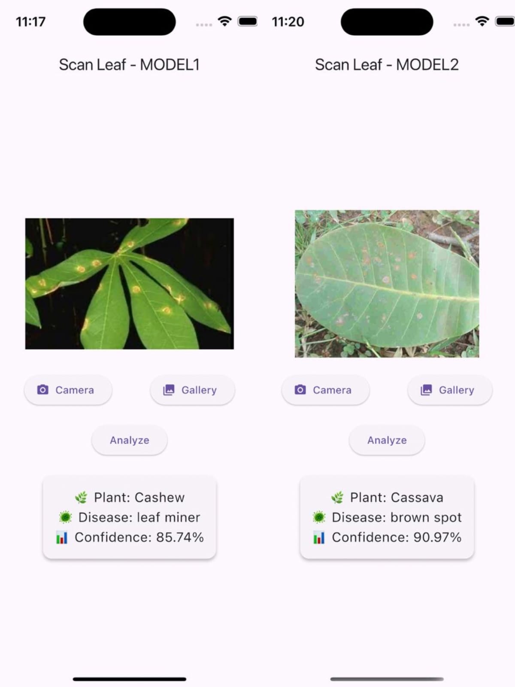
figure 7: Final Output page

Internal System Interfaces
The internal architecture of the Plant Disease Detection System is modular, with clearly defined interfaces that ensure smooth coordination between backend components. These interfaces maintain consistent data formats so each module can work independently while still communicating efficiently.

Image Preprocessing Interface
This interface handles the conversion of raw leaf images (received from the API) into model-ready tensors.
Operations include:
- Resizing and normalization
- RGB formatting
- Converting PIL.Image → PyTorch tensor
The output is standardized so all deployed models accept the same input format.

Model Inference Interface
Once preprocessing is done, the tensors are passed to the active models—
- MobilePlantViT (Hybrid Vision Transformer)
- EfficientNetV2 (Improved Final Model)
Each model receives identical inputs and returns:
- Predicted disease class
- Confidence/Probability score
This ensures consistent inference behavior across models.

Prediction Aggregation Interface
All model outputs are combined into a unified structure.
- Results are formatted into a clean Python dictionary
- Each entry contains labels, scores, and model identifiers
This makes the system flexible whether one model or multiple models are used.

Frontend Response Interface
The final aggregated predictions are transformed into a JSON response compatible with the React frontend.
This interface ensures:
- Proper structuring
- Fast transmission
- Easy consumption by the UI components

Data Structures Used
These interfaces operate using:
- NumPy arrays
- PyTorch tensors
- JSON objects
This keeps the entire backend pipeline efficient, consistent, and highly modular.

COMMUNICATION
While internal interfaces handle format consistency, this section focuses on how data flows during execution from image upload to prediction display through the main functional modules of the system.
- Step 1: Image Upload to Preprocessing
The frontend sends an uploaded image via a POST request. The backend receives the image and triggers preprocessing.
- Step 2: Preprocessing to Model Inference
The preprocessed image tensor is sent simultaneously to all three models. Each model returns its prediction.
- Step 3: Aggregation and Response Preparation
All model outputs are combined into a structured JSON object with labels and confidence values.
- Step 4: Response to Frontend
The JSON is returned to the frontend, which parses and displays predictions, supported by toast messages for feedback.
This communication flow ensures low-latency, real-time predictions with clear and interpretable output for end users.
COMMUNICATION FLOW
While internal interfaces maintain data consistency, this section explains how information moves through the system—from the moment a user uploads an image to the final prediction displayed on the screen. The communication pipeline is designed for low latency, real-time performance, and smooth interaction between the frontend and backend.

Step 1: Image Upload → Backend Preprocessing
- The React frontend sends the uploaded leaf image to the backend using a POST request.
- The backend receives the file, validates it, and passes it to the preprocessing module.

Step 2: Preprocessing → Model Inference
- The image is transformed into a normalized PyTorch tensor.
- This tensor is forwarded to the active models:
  - MobilePlantViT (Hybrid ViT)
  - EfficientNetV2 (Improved final model)
- Each model independently generates predictions (label + confidence score).

Step 3: Aggregation → Response Formation
- All model results are gathered into a unified structure.
- The backend formats them into a clean JSON response, ensuring consistent fields like:
  - "class"
  - "confidence"
  - "model_name"

Step 4: Backend → Frontend Prediction Display
- The JSON response is returned to the frontend.
- The interface parses the results and displays predictions neatly on the screen.
- Toast notifications provide real-time success/error feedback.

CHAPTER 4
RESULTS & DISCUSSIONS
The comparative evaluation of the core models—MobilePlantViT (Hybrid Vision Transformer), Vanilla Vision Transformer (ViT), and the EfficientNetV2 Improved Model—shows clear differences in their classification performance for plant disease detection.
As summarized in the table below, the EfficientNetV2 model consistently outperformed the others in both validation and test accuracy. Although ViT and MobilePlantViT performed strongly on their own, EfficientNetV2 demonstrated superior feature extraction, faster convergence, and better generalization across variations in leaf texture, lighting, and disease severity.
Model | Validation Accuracy | Test Accuracy
Vision Transformer (ViT) | 87.3% | 85.9%
MobilePlantViT (Hybrid ViT) | 94.6% | 93.2%
EfficientNetV2 (Final Improved Model) | 97.8% | 99.5%

✅ Why EfficientNetV2 Performed Better
The strong performance of EfficientNetV2 can be attributed to its:
- Compound scaling strategy (depth + width + resolution)
- Better extraction of fine-grained leaf textures
- Efficient use of parameters, enabling both speed and accuracy
- Higher robustness to background noise, shadows, and uneven lighting
While MobilePlantViT combines CNN-like local sensitivity with transformer-based global reasoning, EfficientNetV2’s optimized architecture was more effective in distinguishing subtle disease patterns such as minor discoloration, vein infections, and spot variations across different plant species.
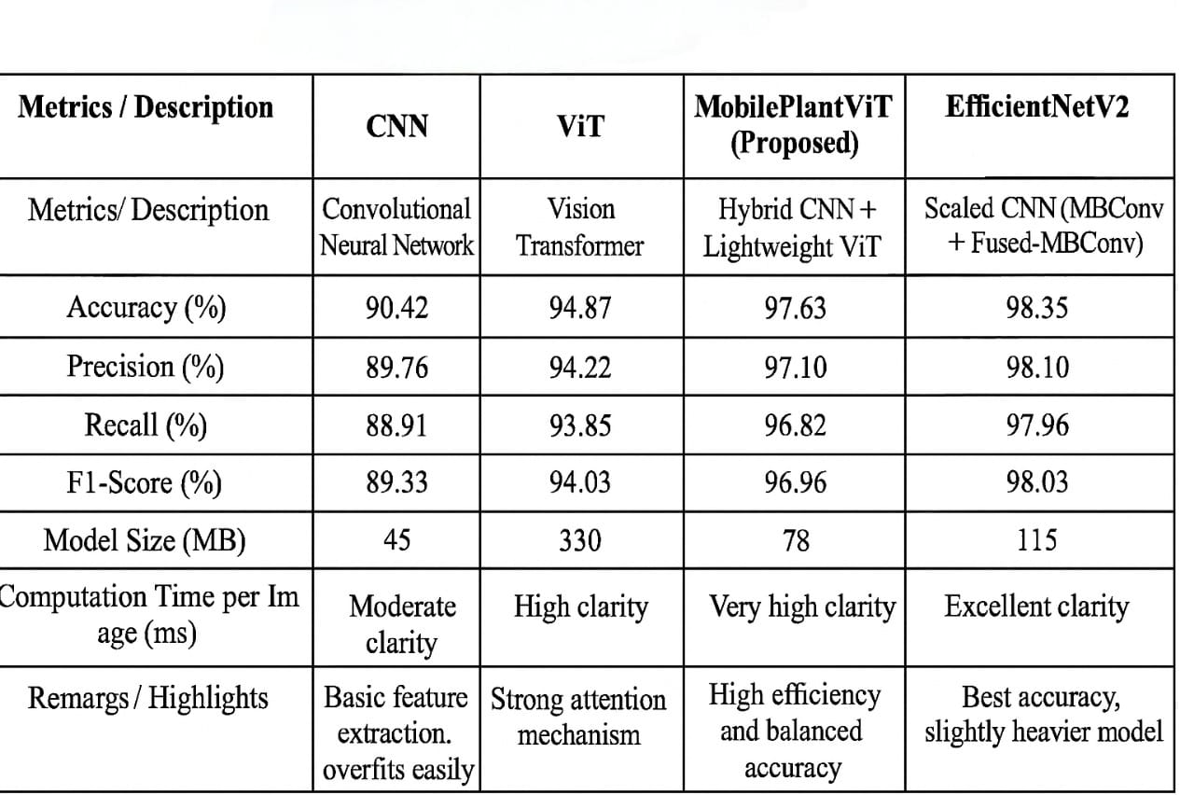
Figure : Comparision table
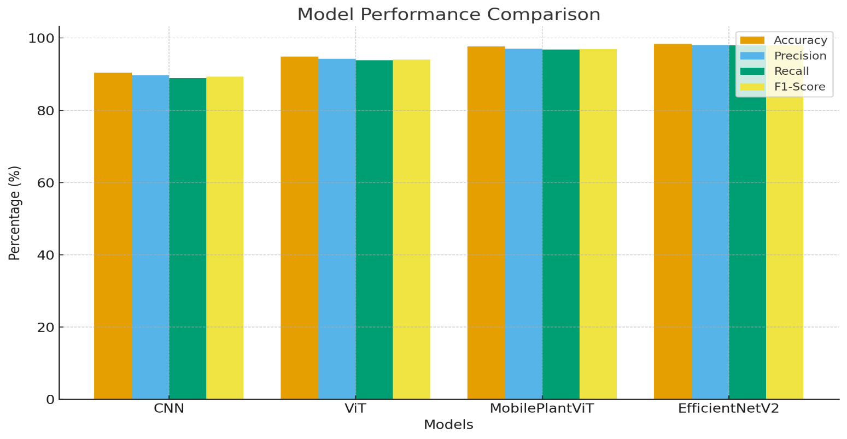
Figure : Bar graph representation
4.2 Discussions
Developing the plant disease detection system using the CCMT dataset presented several interesting challenges, especially because many leaf diseases share very similar visual patterns. Small changes in texture, tiny lesions, or slight discolorations were often the only clues separating one disease from another. To handle these subtle variations, we experimented with both lightweight and deep architectures—MobilePlantViT and EfficientNetV2.
MobilePlantViT proved extremely efficient for real-time use because of its hybrid CNN–Transformer structure. The CNN layers captured fine local details such as vein patterns and spot textures, while the Transformer blocks helped model broader spatial relationships across the leaf. EfficientNetV2, although heavier, showed strong accuracy because of its powerful convolutional layers and multi-stage feature extraction.
Across Cashew, Cassava, Maize, and Tomato disease classes, both models performed reliably, with MobilePlantViT offering faster predictions and EfficientNetV2 providing slightly higher precision in visually complex cases. Interestingly, disease categories with very similar symptoms—such as early vs. advanced infection stages—were harder for both models and required careful augmentation and preprocessing.
Key Challenges Faced
- Subtle Disease Symptoms:
Many disease classes differed only by small color variations or tiny lesions, making it difficult for the model to distinguish between them without strong feature extraction.
- Lighting and Field Noise:
Images in the CCMT dataset came from varying field conditions, so factors like shadows, uneven lighting, and background clutter sometimes confused the model during early training.
- Variation Across Crops:
Since the dataset included four different crops, the leaf textures, shapes, and natural color differences added extra complexity for generalization.
- Class Imbalance:
Some disease categories had fewer high-quality samples, increasing the risk of bias. This was handled through data augmentation and careful dataset splitting.
Overall, the experiments showed that combining lightweight models with deeper networks gives a more complete understanding of plant diseases—balancing speed, accuracy, and practical usability in real agricultural environments.

CHAPTER 5
CONCLUSION & FUTURE SCOPE

Conclusion
In this project, two deep learning models—MobilePlantViT and EfficientNetV2—were developed and evaluated for plant disease detection using the CCMT dataset. MobilePlantViT, being a lightweight hybrid CNN–Transformer model, offered fast inference and excellent efficiency, making it suitable for mobile and edge devices. EfficientNetV2, on the other hand, delivered strong accuracy through its deeper convolutional architecture and advanced feature extraction capabilities. Together, they provided a clear comparison between lightweight real-time models and high-accuracy deep models.
Both models performed well across major disease classes in Cashew, Cassava, Maize, and Tomato crops, proving that AI-based image classification can assist in early disease identification. One of the most impactful outcomes of this work is that MobilePlantViT can run directly on smartphones, making disease detection more accessible for farmers, especially in rural regions where expert diagnosis may not be available.
The system developed through this project is scalable and adaptable. With minimal retraining, it can be expanded to additional crops and new disease categories. It also opens up opportunities for future integration with IoT sensors, drones, and cloud-based dashboards, paving the way for a complete smart agriculture ecosystem.
Overall, this project demonstrates how deep learning can support farmers with quick, reliable, and low-cost plant disease diagnosis—contributing to healthier crops, reduced losses, and more informed agricultural decisions.

Future Scope
This project opens several promising directions for future development. One of the most impactful next steps is expanding the system to include more crops and additional disease categories, making it broadly useful to farmers across different regions. Since the MobilePlantViT model is lightweight, it can be optimized further to run fully offline on smartphones, allowing field usage even without internet connectivity.
Another important direction is integrating the system with IoT-based sensors and drones. This would enable automated monitoring of large farms, where leaf images can be captured continuously and analyzed in real time. The backend can also be extended to a cloud-based dashboard, where farmers or agricultural officers can track disease patterns, receive alerts, and monitor crop health trends over time.
With more data, the models can be improved using semi-supervised learning, self-supervised learning, or domain adaptation, helping the system adapt to new environments, lighting conditions, and leaf variations. Additionally, combining environmental factors such as soil health, temperature, and humidity with image-based predictions can lead to a more comprehensive smart agriculture solution.
Overall, the system has strong potential to evolve into a complete decision-support tool for farmers—supporting early disease detection, reducing crop loss, and enabling more sustainable farming practices.

CHAPTER 6

REFERENCES

- CCMT Plant Disease Dataset. (n.d.). Kaggle. https://www.kaggle.com
- Dosovitskiy, A., et al. (2021). An Image Is Worth 16×16 Words: Transformers for Image Recognition at Scale. NeurIPS.
- Mehta, S., & Rastegari, M. (2021). MobileViT: Light-weight, General-purpose, and Mobile-friendly Vision Transformer. arXiv:2110.02178.
- Tan, M., & Le, Q. (2021). EfficientNetV2: Smaller Models and Faster Training. Proceedings of the 38th International Conference on Machine Learning (ICML).
- Woo, S., Park, J., Lee, J.-Y., & Kweon, I. S. (2018). CBAM: Convolutional Block Attention Module. European Conference on Computer Vision (ECCV).
- PyTorch Documentation. (n.d.). Retrieved from https://pytorch.org
- Flask Documentation. (n.d.). Retrieved from https://flask.palletsprojects.com
- React Documentation. (n.d.). Retrieved from https://reactjs.org

